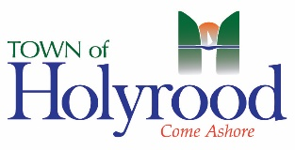
Town of Holyrood
12 Days of Easter Online Egg Hunt
CONTACT INFORMATION
Child’s Name: | Address:
Phone #: | Parent Email Address:

DAY 1 – APRIL 1ST |  | DAY 7 – APRIL 7TH
 | Location:  Color: | Location:  Color:
DAY 2 – APRIL 2ND |  | DAY 8 – APRIL 8TH
 | Location:  Color: | Location:  Color:
DAY 3 – APRIL 3RD |  | DAY 9 – APRIL 9TH
 | Location:  Color: | Location:  Color:
DAY 4 – APRIL 4TH |  | DAY 10 – APRIL 10TH
 | Location:  Color: | Location:  Color:
DAY 5 – APRIL 5TH |  | DAY 11 – APRIL 11TH
 | Location:  Color: | Location:  Color:
DAY 6 – APRIL 6TH |  | DAY 12 – APRIL 12TH
 | Location:  Color: | Location:  Color:

